Web322 final project

Dmytro Andriushchenko 131641185 dandriushchenko@myseneca.ca

A table of contents

|  |  |
| --- | --- |
| Project description | 2 |
| Home page | 3 |
| Rooms aka “Burrows” | 5 |
| Room details | 7 |
| Sign Up form | 8 |
| Log In form | 11 |
| User’s profile | 14 |
| Admin’s profile | 17 |
| Room addition | 18 |
| Admin View | 19 |
| Web app structure | 21 |

Homepage shows basic navigation menu, search form, some information about webapp and hot deals.

Not logged in user can search, view rooms but can’t do anything more. If he hits sign Up button form will ask him to ender his credentials for submission. If data is not entered or invalid or this account already exists than user will be informed. After successful sign up user will be redirected to login page where he’ll have to ender his data (email and password). If data is valid he will be redirected to his profile page, where he can edit his profile. Also Signed in user can book any available room. After successful booking this room will not be able for booking for other users.

Admin user has more rights then regular user. He can add/edit/delete rooms from and to DB.

Search form will filter all rooms and will show just those that user was looking for. If user selected “Anywhere” in search form, than webapp will show all rooms available for booking.

<https://github.com/Charon89/FantazyStays> GitHub repository

<https://fantazystays.herokuapp.com/> Deployed on Heroku

3rd party packages used in this project:

*"@sendgrid/mail"*: "^6.4.0",

*"bcryptjs"*: "^2.4.3",

*"body-parser"*: "^1.19.0",

*"dotenv"*: "^8.2.0",

*"express"*: "^4.17.1",

*"express-fileupload"*: "^1.1.6",

*"express-handlebars"*: "^3.1.0",

*"express-session"*: "^1.17.0",

*"method-override"*: "^3.0.0",

*"mongoose"*: "^5.7.12",

*"mongoose-unique-validator"*: "^2.0.3"

Home page with search form and navigation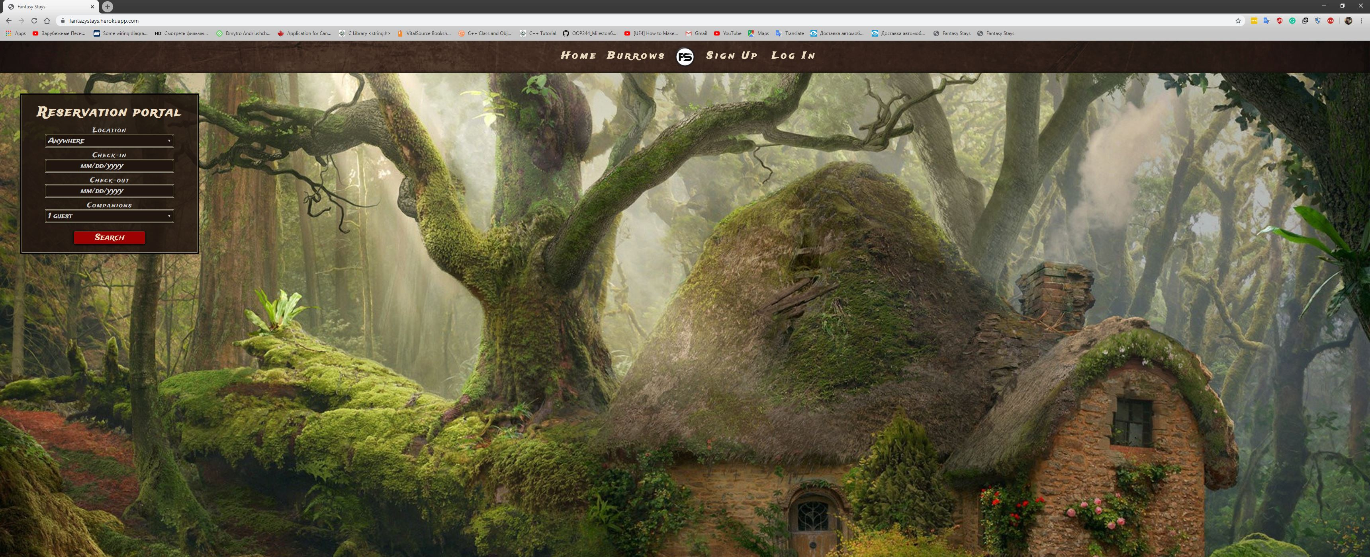

**Home page**

The bottom of the home page with “Hot deals” and a footer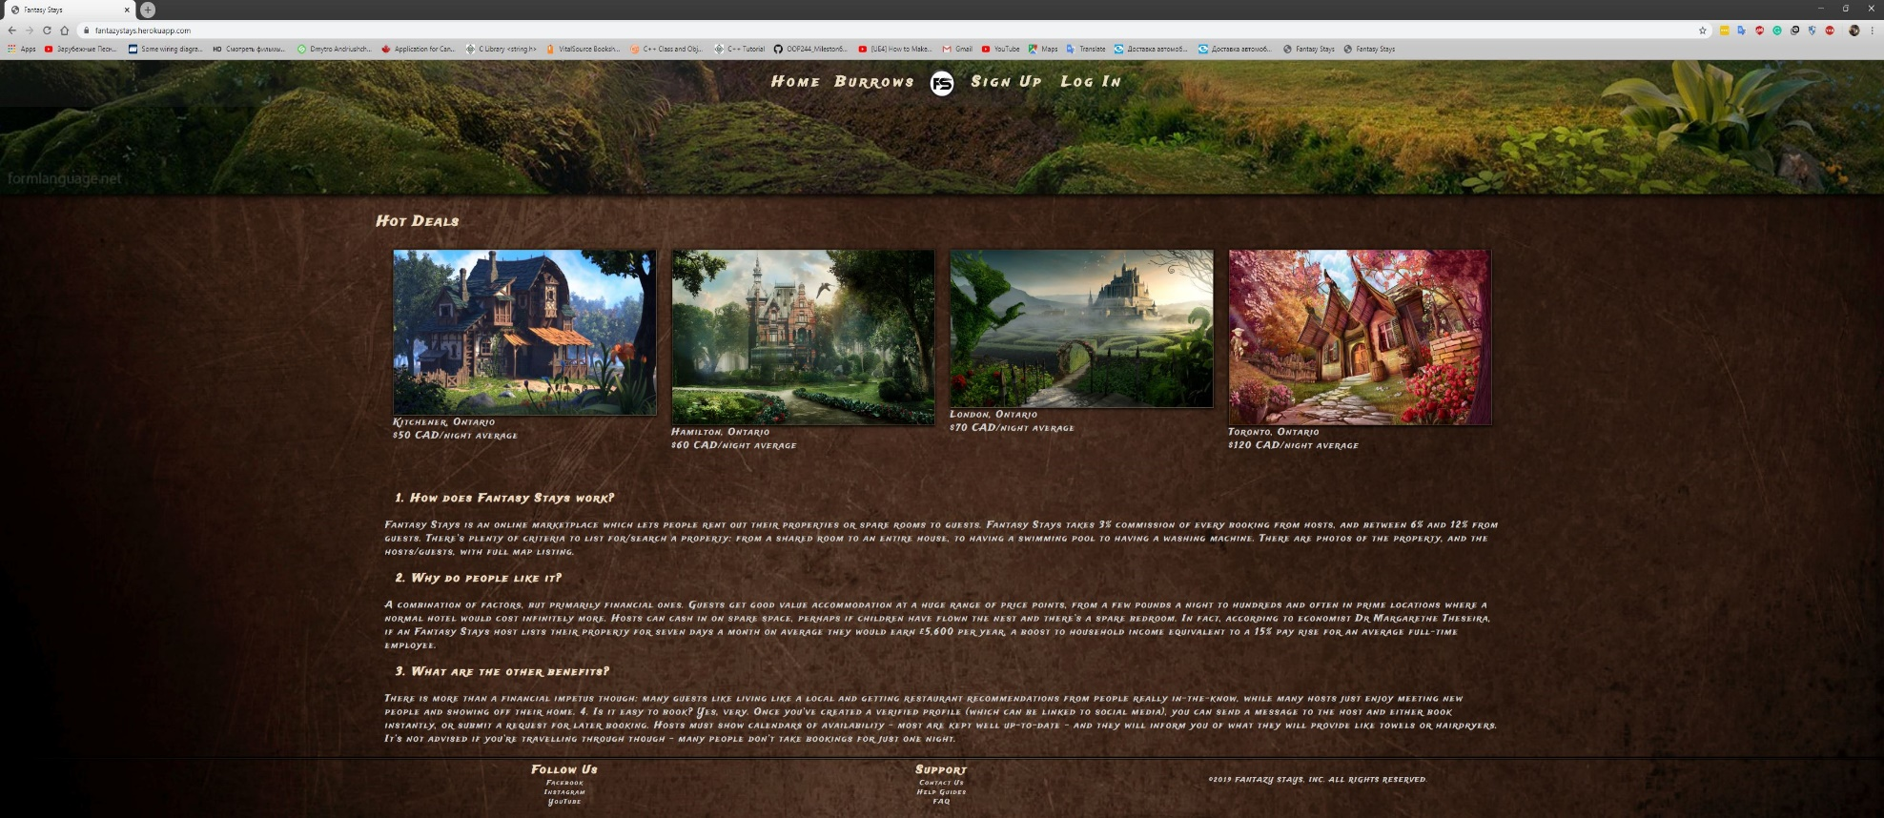

**Bottom of the home page**

List of all available rooms aka “Burrows” 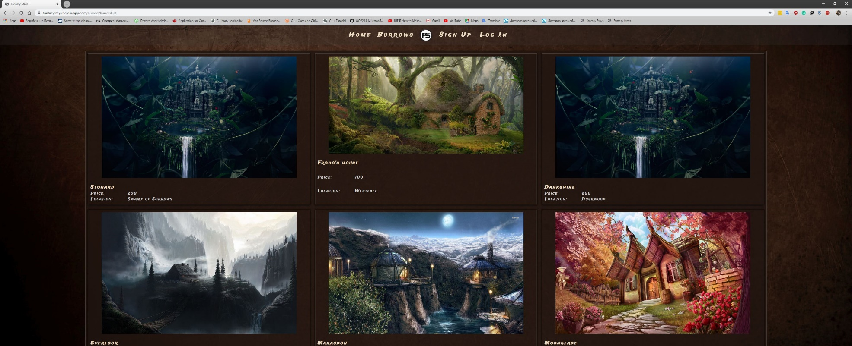

**Burrows**

The bottom of the “Burrows” page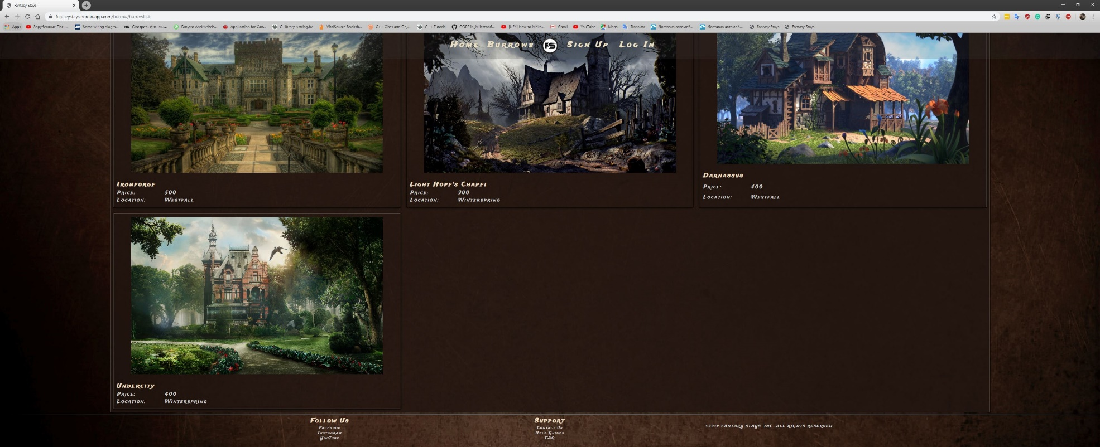

**Burrows**

If user click on specific “Burrow” he will see it’s detailed information and book button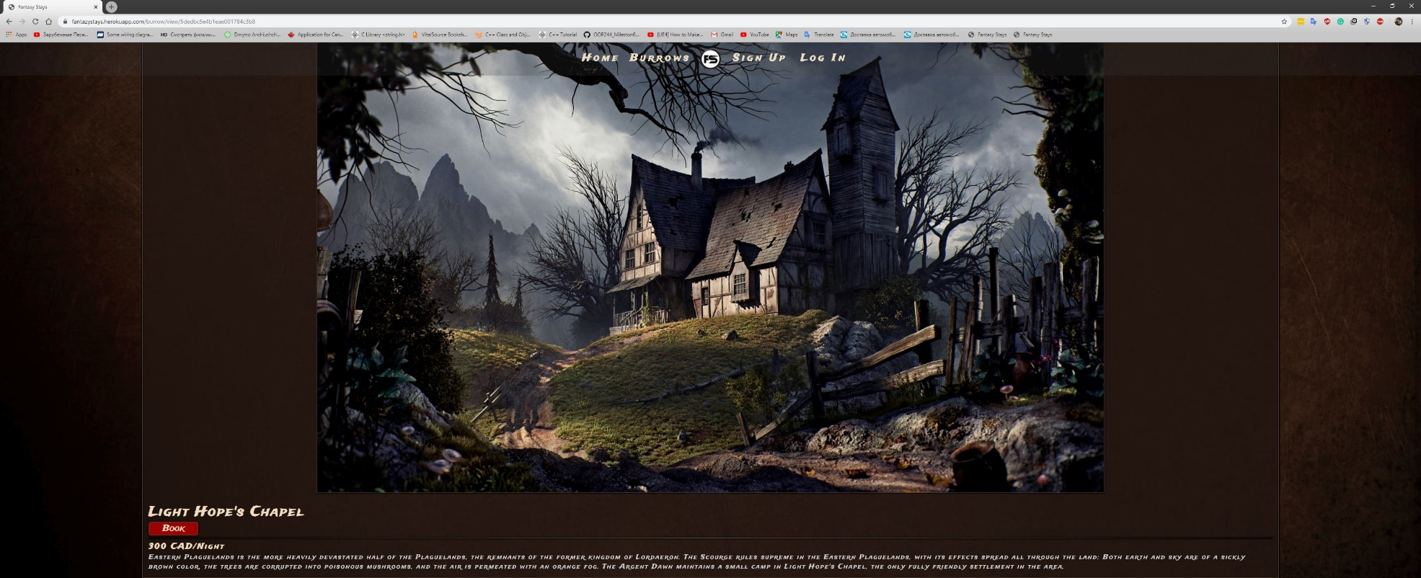

**Detailed information**

Sign Un form will ask user to enter his credentials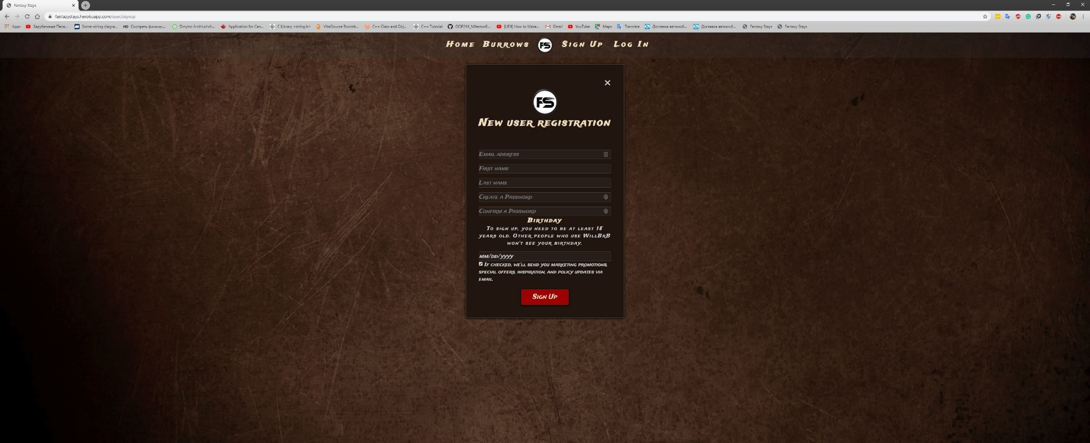

**Sign Up form**

If user left black fields, system will tell him which fields must be filled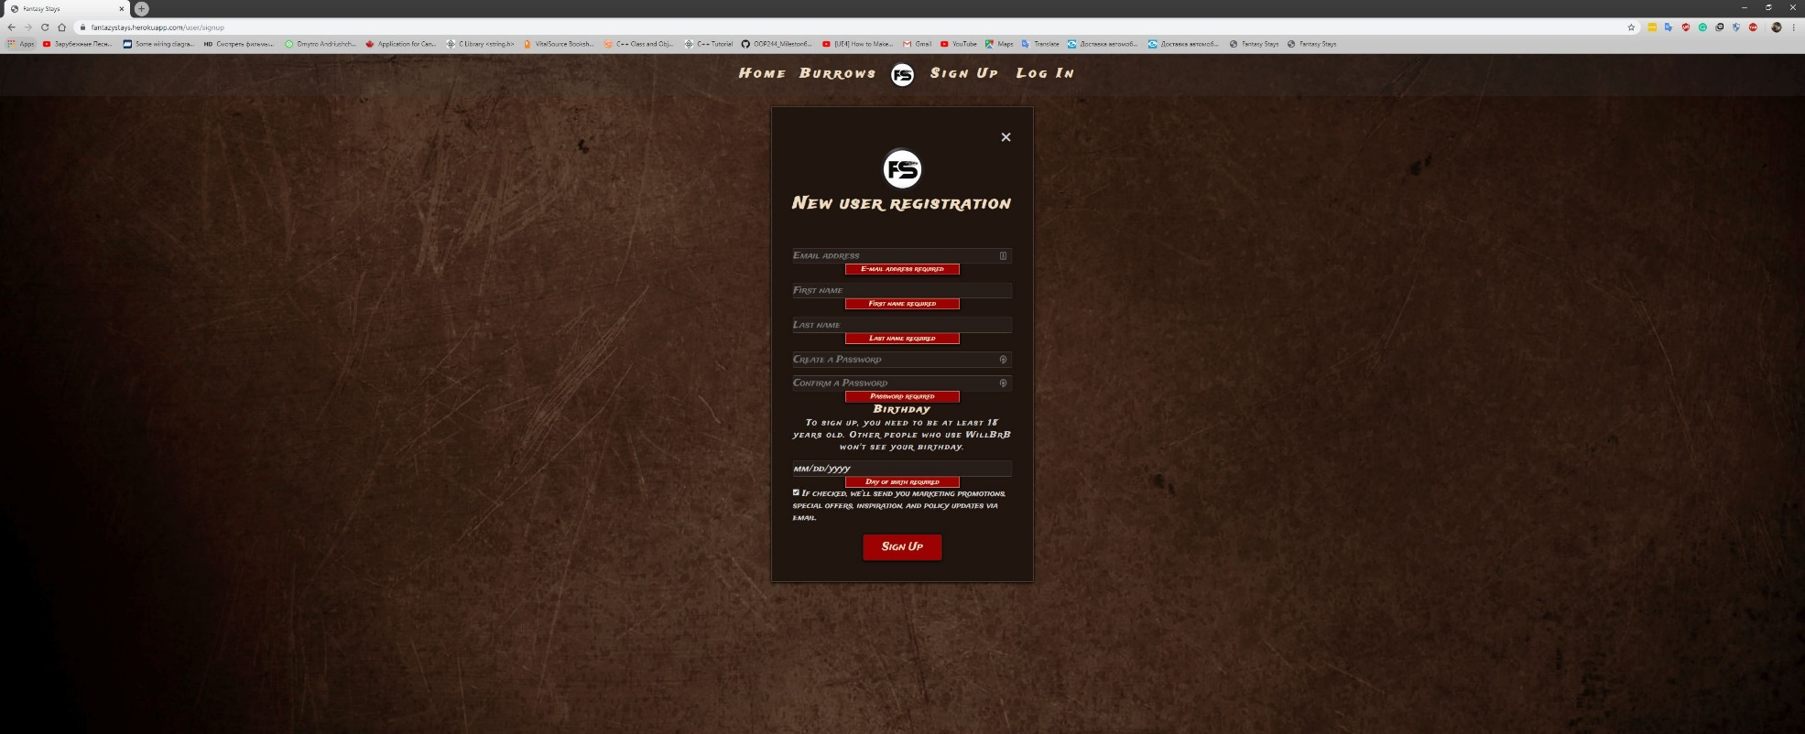If such email already in the DB user will be informed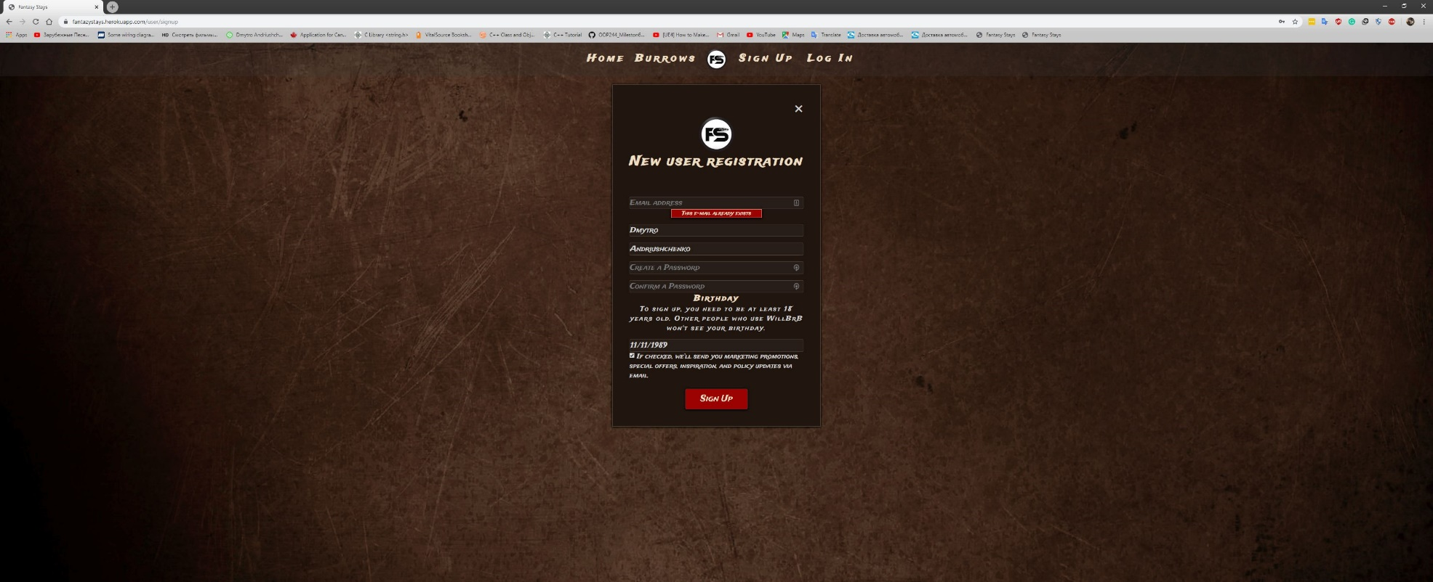

**Sign Up form**

**Sign Up form**

Login form asks to enter email and password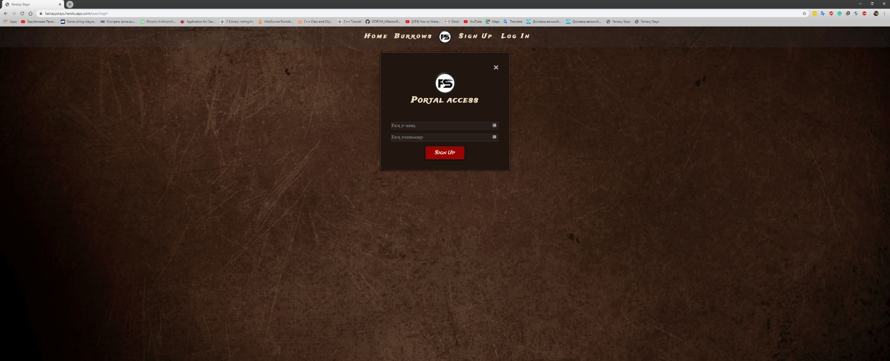

**Log In**

If fields are black system will show what must be filled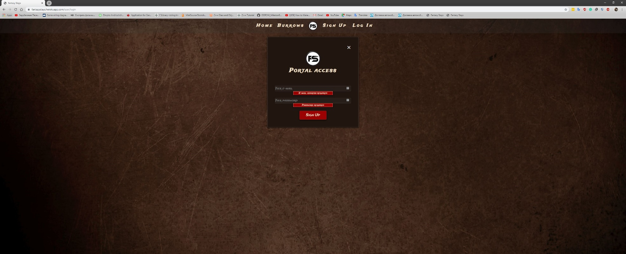

**Log In**

If user enered email that is not in DB system will tell that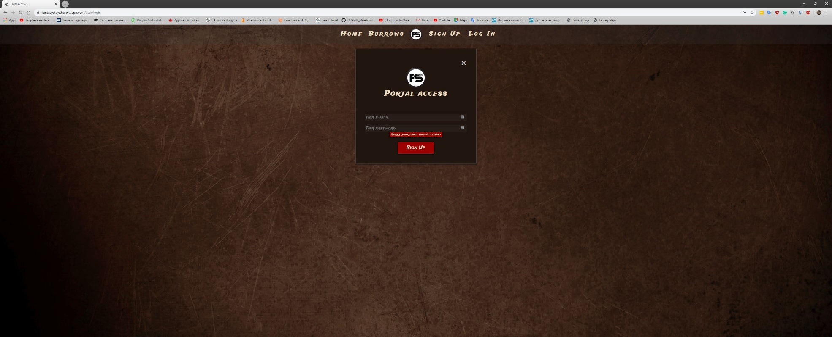

**Log In**

Regular user’s profile page with basic information and button to edit information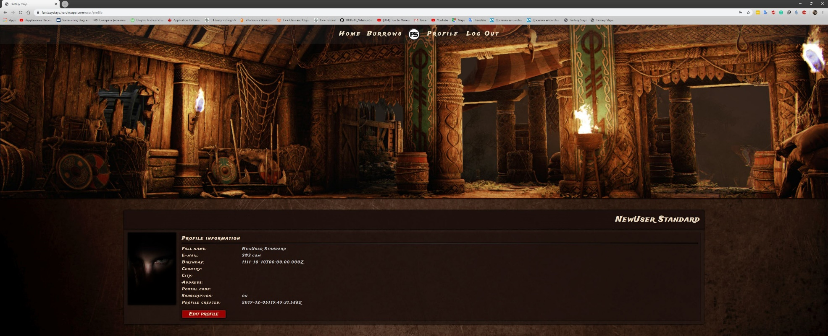

**User profile**

User edit form. User can change him profile picture, and information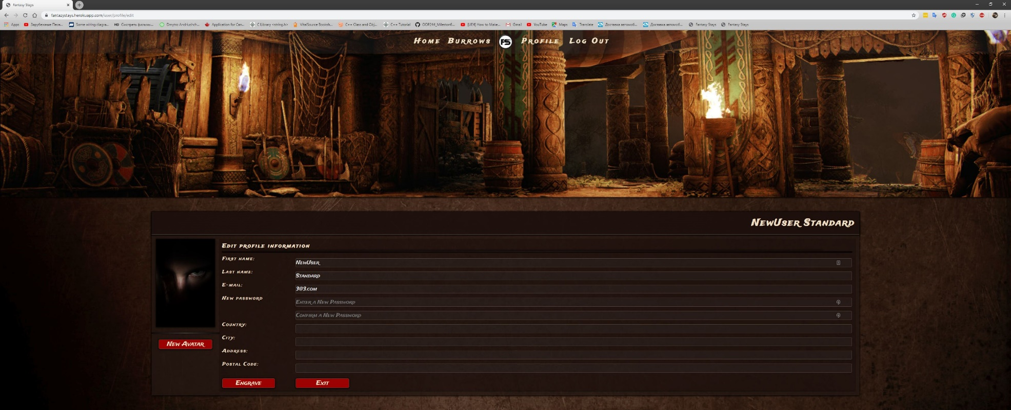

**User profile edit**

Modified user’s profile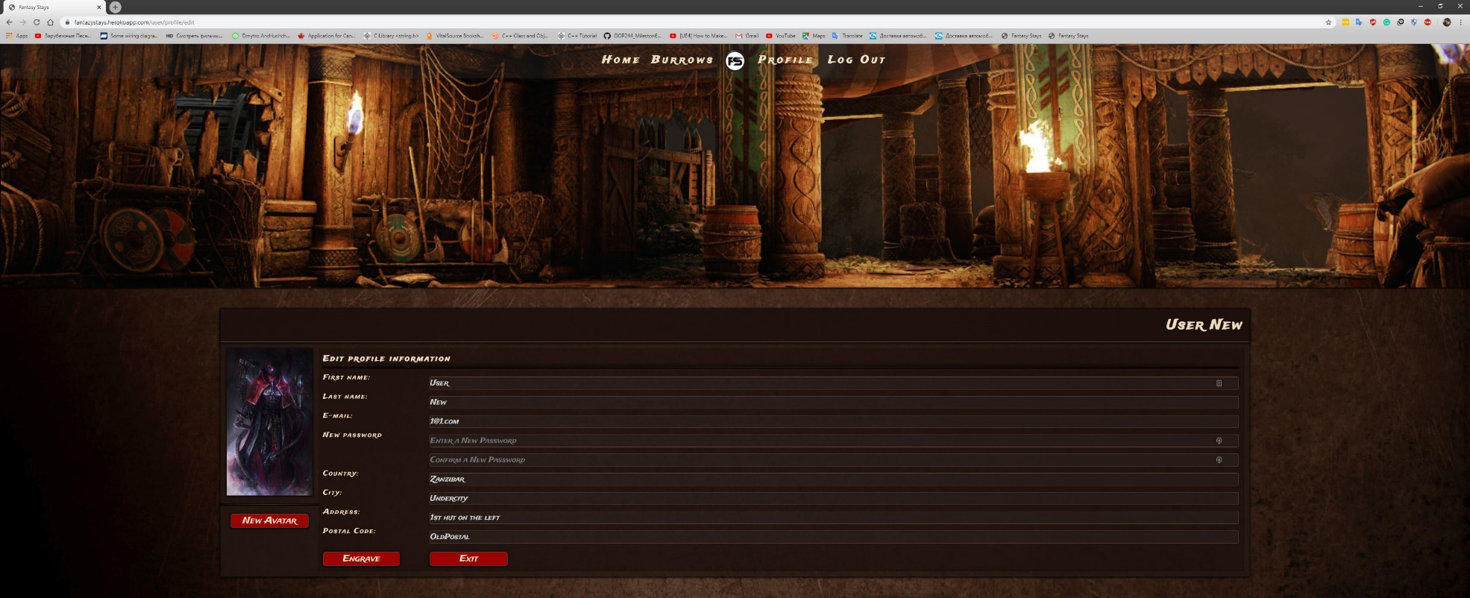

**Modified user profile**

Admin profile page. Where he can edit his information and add new “Burrow”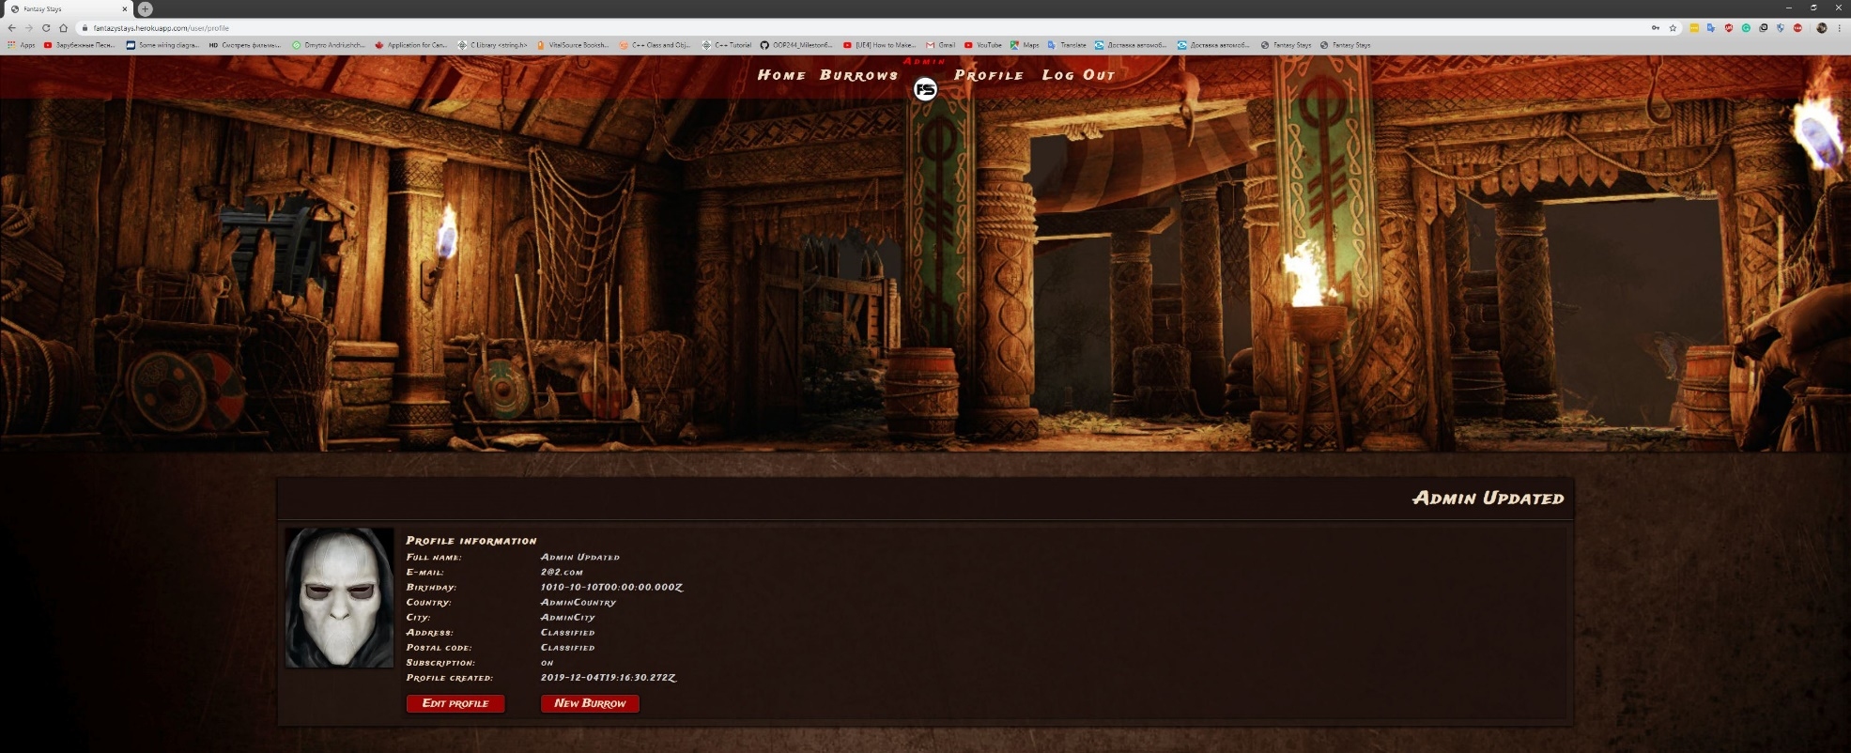

**Admin profile**

“Burrow” additiom page promts for information and picture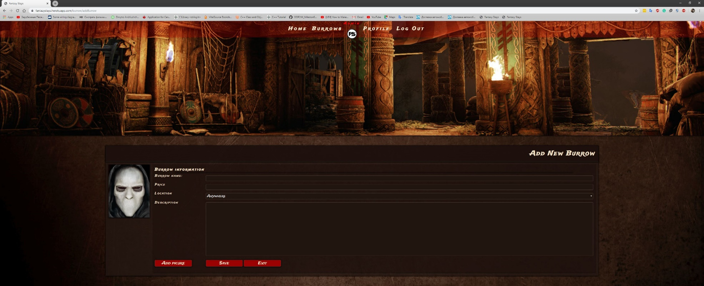

**Room addition form**

List of rooms from admin account where he has 3 options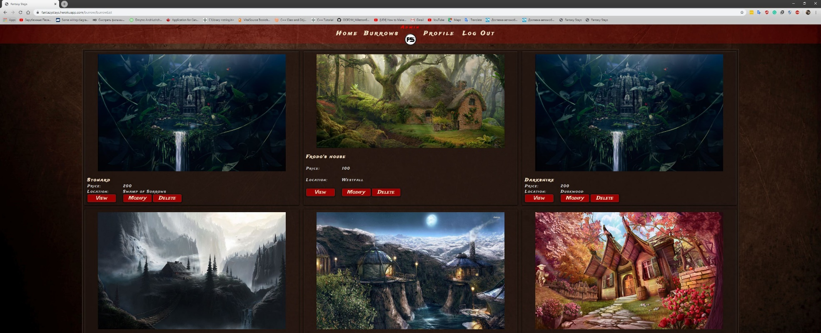

**Admin view**

Admin Edit Room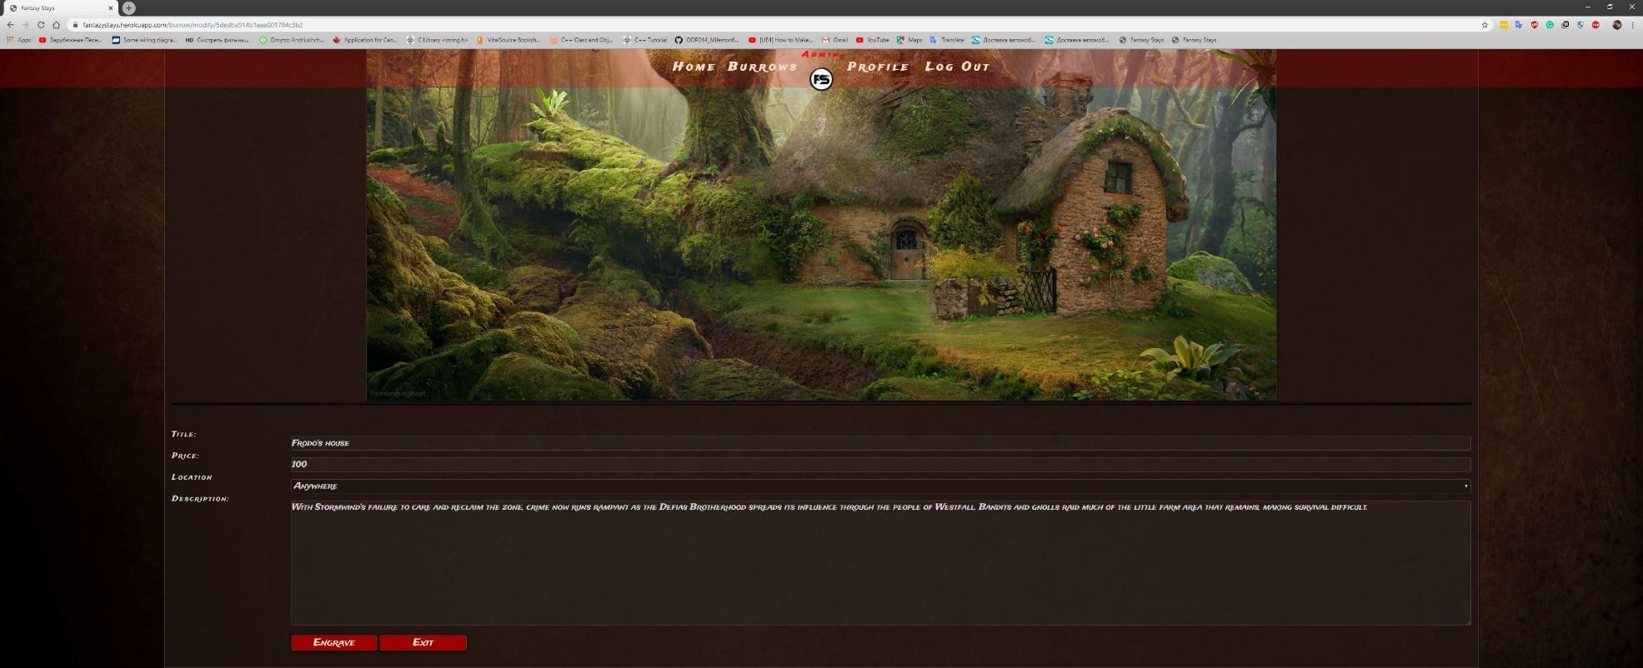

**Admin room edit**

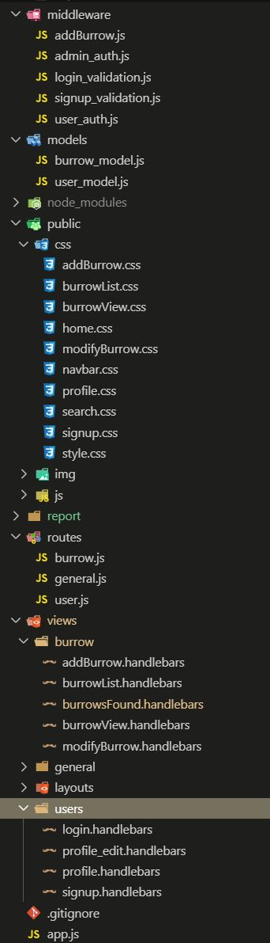

**Web app structure**